**Micro frontend:**

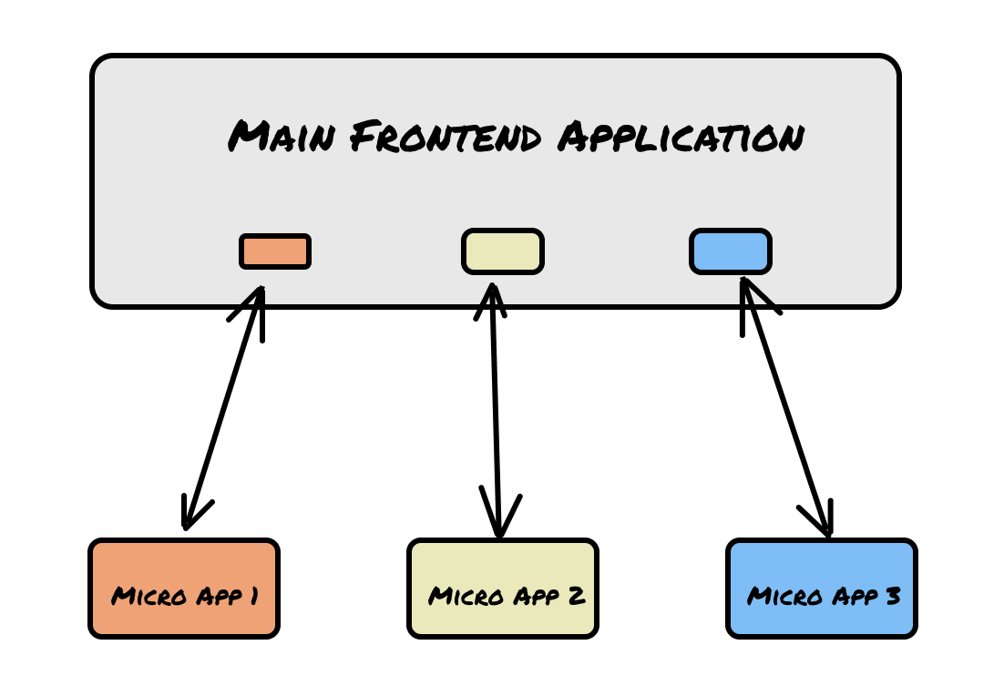

**Advantages:**

1. Develop smaller UI components as a micro frontend app and use in different applications.

**Problems:**

1. If a particular micro fronted app is down it might lead to an incomplete page or might take down an entire section of the application, which can lead to bad user experience or simply render the application useless for the user.
2. Setting up a Micro Frontend architecture can be quite expensive to implement. You might end up paying a lot more to set up network infrastructure to hold all the Micro Frontends, and having to do so for each time-zone.

**Tutorials:**

<https://dev.to/bitovi/how-to-build-a-micro-frontend-with-webpacks-module-federation-plugin-n41>